Rights Respecting Schools: The article of the week for this week is

Article 7: Every child has the right to be registered at birth, to have a name and nationality, and, as far as possible, to know and be cared for by their parents.

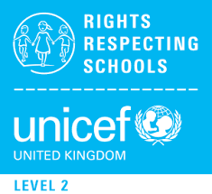
RRS Activity choices:

Option 2: In 2015 a French court said a couple couldn't call their daughter Nutella – like the chocolate spread. Some other countries also have rules about what you can and can't name a baby too - can you find out any of these countries and their naming restrictions? What factors do you think parents should consider when choosing a name for their baby?

Option 3: Draw an identity hand! Draw around one of your hands, write your full name in the thumb area, in the next finger, write your date of your birth, put the country you call home in the next finger. Then in the last two fingers, write the names of two adults who are important for you, like you parents, carers or grandparents. Draw the flag of your nationality on the palm. Finish your picture with your favourite colours or designs.

Option 1: Ask your family why you have the name you have. Did they have another name for you What does your name mean? Does it suit your personality? Research the most popular names in the UK. What were the most popular names in the year you were born?

