Rights Respecting Schools: The article of the week for this week is

Article 14: Freedom of thought, belief and religion. This article tells us that every child has the right to think and believe what they choose and also to practise their religion, as long as they are not stopping other people from enjoying their rights. Governments must respect the rights and responsibilities of parents to guide their child as they grow up.

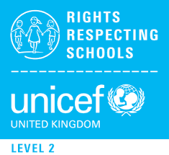
RRS Activity choices:

RS RRS Choice 3
RRS

RRS Choice 3: Can you think of some items or religious artefacts that are important in more than one religion? For example, candles, prayer beads and head coverings. Choose one and draw a scene of a child using this item in one of these religions and explain the meaning of this object.

RRS Choice 2: Food choices are really important to some people. Find out about the food rules of veganism or a specific religion. If you have the ingredients at home, why don’t you have a go at making a dish with your family?

RRS Choice 1: Why do you think religious buildings are important? Think of and draw a building that is important to you or make a sculpture of one of these buildings using things you can find around the house (old cereal boxes, empty toilet roll etc.). This could be a religious building like a church or a temple, or even a school or a library. Write a sentence or two about why this building is important to you.

