Rights Respecting Schools: The article of the week for this week is

Article 28- The right to an education.
This article tells us that:
- Every child has the right to an education.
- Primary education must be free and different forms of secondary education must be available to every child.
- Discipline in schools must respect children’s dignity and their rights.
Richer countries must help poorer countries achieve this.
This article is more important than ever just now.
Choose one of the three challenges to explore this right in more detail.

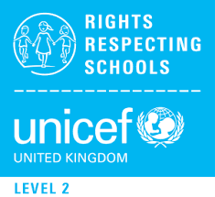
RRS Activity choices:

RRS Challenge 3:
Think about your own learning for a few minutes – both in school and outside of school.
- What do you love learning about the most?

RRS Challenge 2:
Talk to relatives or friends who are older than you and ask them what school was like for them. What are their best and worse memories? How has school changed? How do you think knowing about rights improves life and learning in school?

RRS Challenge 1:
Article 28 says that ‘Discipline in school must respect children’s dignity’. What do you think this means in practice? Imagine you are the Headteacher of a new school, as well as ‘dignity’, what other three values would you place at the heart of your school? How can you ensure that everyone respects these values? Design a school motto or logo to illustrate this.

