Rights Respecting Schools: The article of the week for this week is

Article 15 – Freedom of association
Every child has the right to meet with other children and to join groups and organisations, as long as this does not stop other people from enjoying their rights.

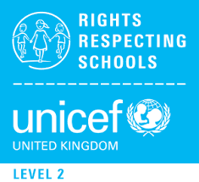
Some activities to help you think about Article 15

RRS Activity choices:

Activity 1
Talk to someone in your home or a friend on the phone or safely online
about the different ways that you can get to know new people–
some funny memories might come up about the first time you met one of your friends

Activity 2
Think about a group or club you are part of. Create a poster or leaflet to encourage other people to join. Make sure to list all of the reasons why it is a good idea to join this group. During these times it can be difficult to stay in touch with other young people and groups that we are part of. Make a list of 5 children that you would like to get in contact with. Write them a letter or video call them this week to find out how their week has been.
Activity 3

Can you think of any fictional or historical characters who have had their right to associate with others restricted or reduced. How did this feel for them? How did they overcome this.

Activity 4
Get together safely with your friends online and discuss the issues affecting you during this time of lockdown. What messages or questions do you have for school and politicians, linked to Article 15. Create a flier or a digital message to get your points across.

Something else to think about…

Sometimes people say Article 15 is ‘The right to friends’ but that’s not what the article says! Why do you think that there isn’t actually a ‘Right to have friends’ in the CRC?
Do all the people in the clubs and groups you belong to have to be your friend?

