Article 19 – Protection from violence, abuse and neglect
Governments must do all they can to ensure that children are protected from all forms of violence, abuse, neglect and bad treatment by their parents or anyone else who looks after them.
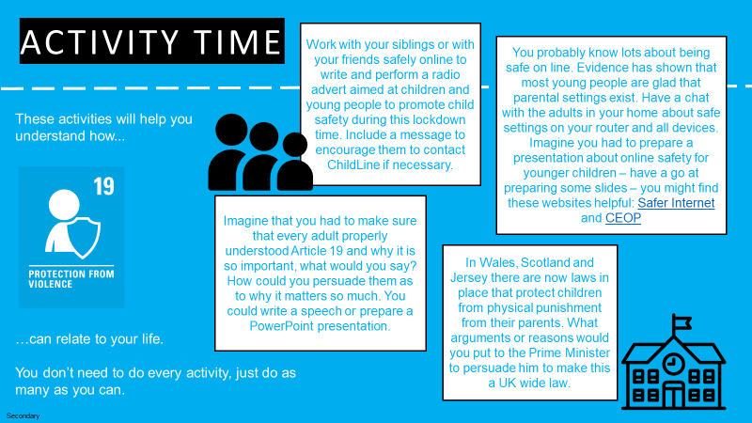
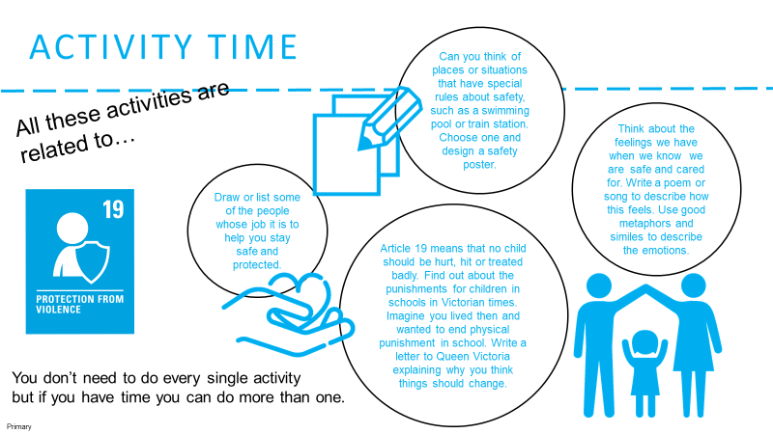
Think about the staff in school who look after Child Protection, Safeguarding and other support such as counselling and emotional support. Think about the skills and qualities those people have to do that work. Write a letter or a poem to sum up what they do for the pupils at your school.
Try to find somewhere quiet and spend a few minutes being quiet and still. Then think about these questions:
- Who are the people who make you feel really safe and secure? How does it feel to be with them?
- In this time when most people are away from school, how can they get help if they are feeling unsafe?
- Think of the people you know who make you feel especially safe and secure – think about a way you can thank them for this and let them know how much it matters to you.

