Calming star

Which unhelpful feeling sometimes bothers you - are you sometimes worried, upset or scared? Write this feeling on the line in the middle of the star, or draw your own star with as many points as you like.Talk about things you could maybe do to help you feel better.
e.g. ‘When I feel upset I can …chat to my dad
draw a picture
take 5 deep breaths
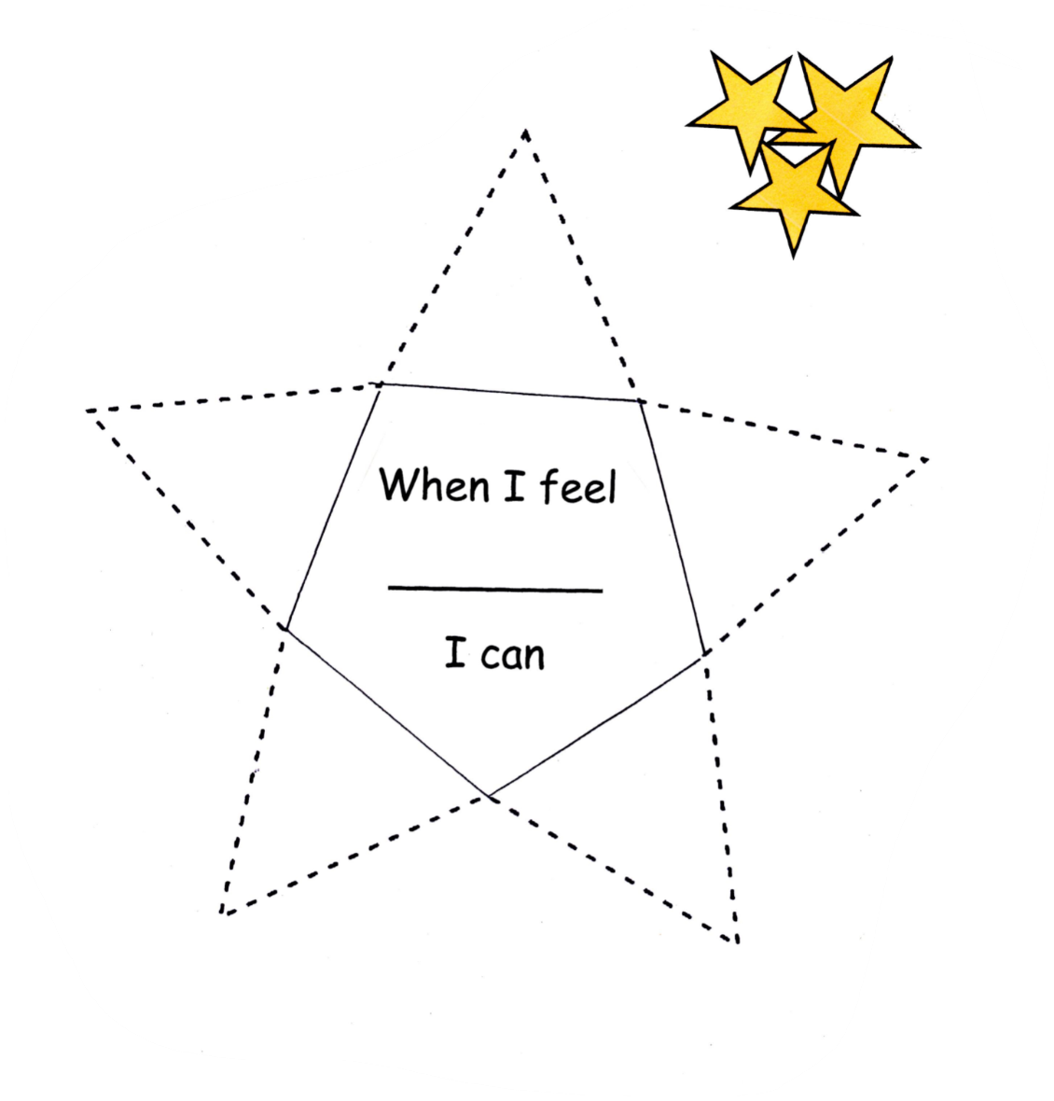
Write your ideas in the points of the star. Decorate the star, and then cut it out and fold it up to make a pyramid. You can keep it for whenever you need it.

