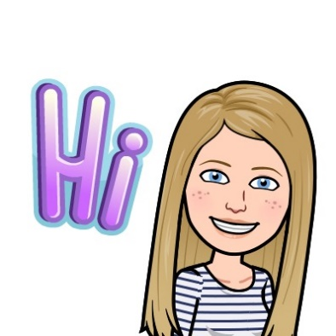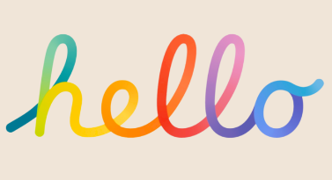

**Literacy**

**Reading** — In Primary 2, children will be read independently and applying reading strategies that are being taught in class. These include sounding out unfamiliar words, using picture clues and using their knowledge of common words. Primary 2 will continue using these strategies to read with more fluency and expression as well as take part in various active and written activities based on the stories they have read.

**Phonics –** We will continue to focus on new diagraphs with more of a focus on identifying, reading and writing words of the week.

**Writing:** Our writing sessions continue to be our highlight of the week. We will be kicking off the term by writing all about our Christmas holidays before moving onto writing an imaginative story about the famous Loch Ness Monster. We will also be focusing on Talk for Writing towards the end of this term too.

Our PE days and times will be:

**Tuesday** and **Thursday**.

Gym kits are required for these days and should include a polo shirt or t-shirt, shorts and a pair of gym shoes or trainers.

This term we are going to cover:

* Gymnastics
* Hockey
* Bat and Ball Games

**Numeracy and Maths**

In Term 3 we will be covering;

* Time
* Subtraction
* Information Handling
* Symmetry

Primary 2 will also be focusing on number and shape sequences, odd and even numbers as well as continually recapping addition and subtraction strategies.

We will be learning using a range of concrete materials and through play. This will allow children to explore and investigate all Numeracy concepts we are learning in class.

**IDL -** We will be beginning 2024 by focusing on our month of Scots. Primary 2 will be learning ‘Soacks’ as part of our annual Poetry competition. We will also be learning about Dinosaurs in term 3.

**Primary 2**

I hope you all had a wonderful Christmas break!

Here is a snapshot of what   
Primary 2 will be getting up to in Term 3.