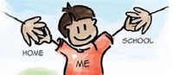 | Struthers Primary School
Primary 7
Monday 15th June – 26th June 2020 (2-week plan)

The following activities are suggestions of fun activities that your child can complete over the next 2 weeks. Pupils can choose the activities they would like to complete. Please feel free to share photographs on Microsoft Teams or Seesaw.
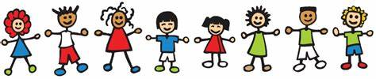
Transition Activities

Complete the Transition booklet about your new school, which can be found on the website or on your Microsoft Teams Page.  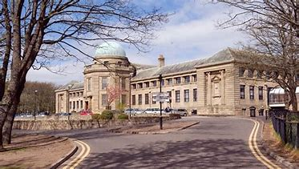 |  | 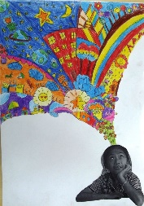  An all about me task?  Draw colourful images that are unique to you bursting from your imagination. Take a picture of yourself and add below if possible.
Health and Wellbeing

Joe Wicks/ ALO Yoga  Join in with Joe Wicks or visit https://www.aloyoga.com/pages/alo-gives-program-all-yoga-videos and complete a yoga session! | Feelings  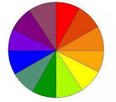  Create a colour wheel and choose an emotion for each colour. In each segment, draw something that has made you feel that emotion during lockdown e.g. yellow - happy – my scooter | Internet Safety  Now that we are using the internet on a daily basis for our tasks, what are some of the things you think you need to be careful of when doing so?Make a poster for the younger pupils in the school using the information you have to tell them how to be safe on the internet.
Art | Construction | Outdoor Learning
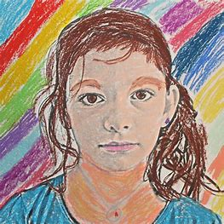  Draw a self-portrait to give to your new teacher for when you return in August. Try to show a little bit of your personality in your artwork! | Using any construction material you have (Lego, Minecraft, paper, card, cardboard etc.) create a space shuttle.  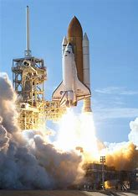 | 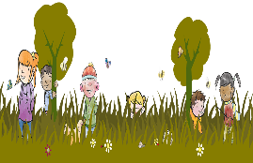  Take a trip to Fullarton Woods/the beach with your adult…  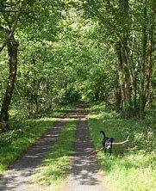
STEM | 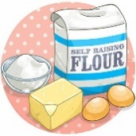  Food Technology | Drama/Music
Terrific Scientific DIY: How to build your own bottle rocket  https://www.bbc.co.uk/teach/terrific-scientific/KS2/zr63d6f | Warning: You must have your parents/guardians permission for this…  https://www.bbcgoodfood.com/howto/guide/how-make-slime | Disney have lots of resources for you to explore. I recommend ‘The Lion King’ as it was our school show this year.  https://disneyonstage.co.uk/education/
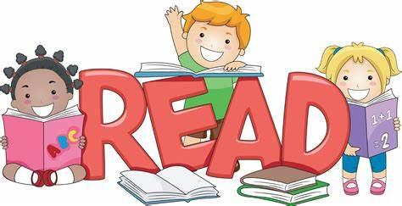  Literacy | Maths/Numeracy | Virtual School Trips
Reading: Please try to read for at least 15 minutes per day. You could continue Divided City or a book of your choice.  Writing: Ambition  - Write a short story about what your life will be like in 15 years.  - Read/watch video of ‘Beautiful Ambition’. Write your own poem about your hopes and dreams for the future. | - Twigs are great for making shapes and demonstrating a variety of angles. Challenge children to make as many shapes as they can with right-angles.  -Ask children to explore outside and collect various natural materials such as sticks, leaves, pine cones. Then measure the size of each object  Daily Speed/Distance/Time chilli challenges will be available on website and Teams | 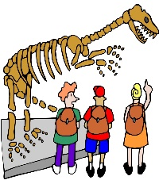  https://www.equityschooltravel.co.uk/virtual-school-trips  I recommend No. 5 – Trip to NASA

