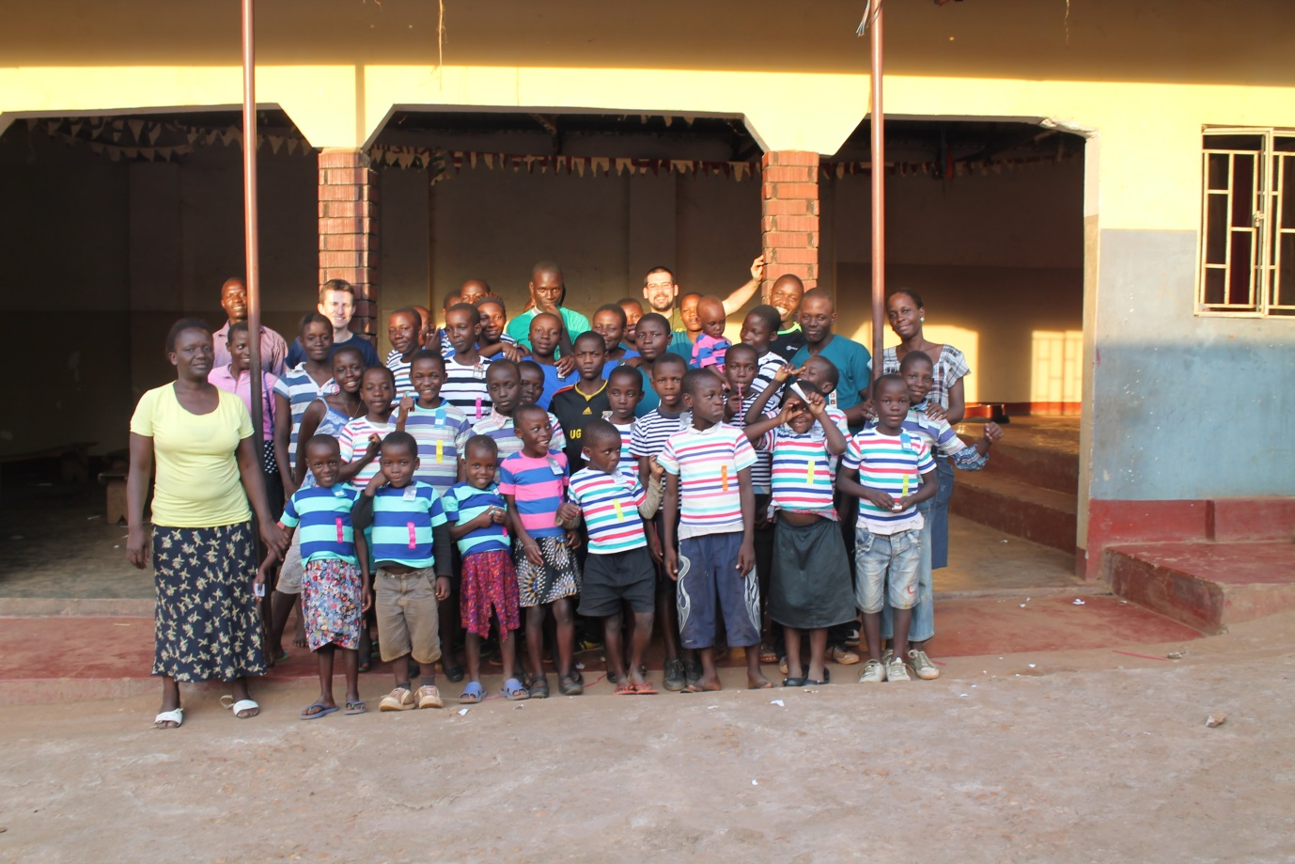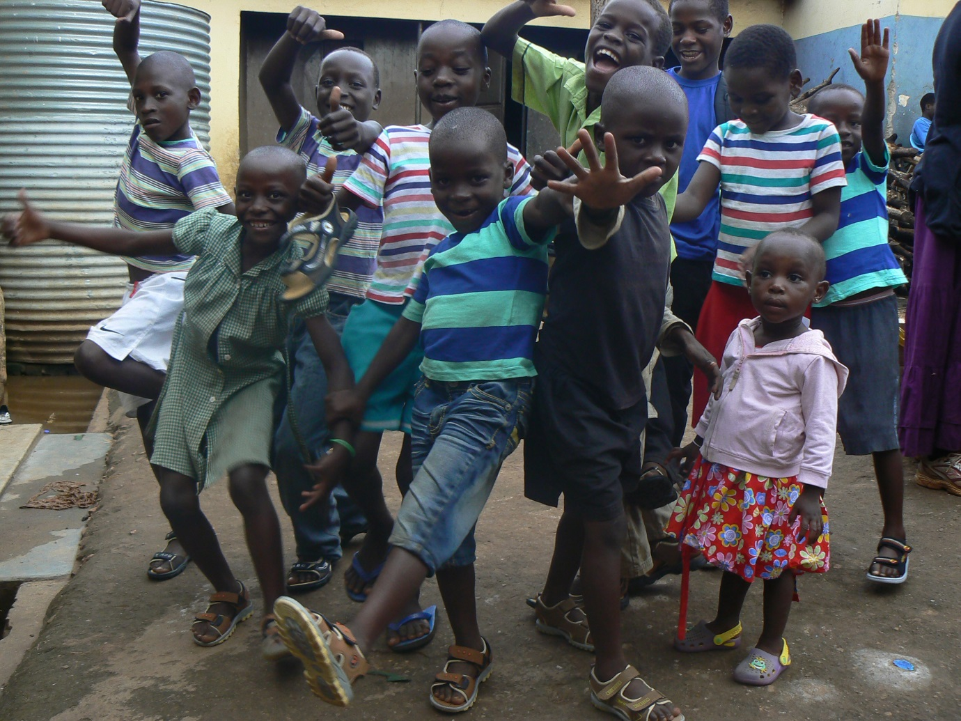

Article 20If a child cannot be looked after by their family, governments must make sure that they are looked after properly by people who respect the child’s religion, culture and language.

**Meet our new friends in Uganda. They stay at Capstone Childrens Home in Lugazi We have sent clothes and money to support them which we have collected at our summer and Christmas Church Services. …..£350 so far….**