Super Spicy Chilli Challenge
Calculating the Distance
We are learning to use a formula to calculate the distance of an object.
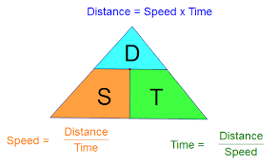

Solve the problems below by calculating the distance each object has travelled:
- A plane left Benidorm at 1325 and arrived in Glasgow at 1625. The plane flew at an average speed of 420.5mph.
a) How long did the flight take?
b) How many miles did the plane cover to reach it’s destination?
- A tug boat left Kincardine at 2:50pm and sailed at a steady speed of 15mph along the River Forth.
How far was the tug boat from Kincardine at 6:55pm?
- What distance was covered by a person strolling at 2.5km/h for 3 and a half hours?
- Calculate the distance travelled by a rocket, doing 2543 km/h for 22 hours?
- Avril travels in her car at an average speed of 43mph. She leaves her house at 8:23am and arrives at work at 9:53am. What is the distance that Avril has travelled to get to work?
- A fire engine is on call and drives at an average speed of 87mph. The fire engine set off at 1303 and arrive at the destination at 1333. What distance has the fire engine travelled?
- Gerry is in the middle of a hopping competition. He hops on average at 0.5mph for 8 half hour intervals. What distance has Gerry travelled altogether?
- A plane travels for 4.5 hours at an average speed of 575mph. What distance has the plane covered?

b) A warden wants to know the length of the path from D to A.
He walks along the path. It takes him 47 minutes however he took 2, 5 minute breaks. He also knows that he walks at average speed of 3 and half miles per hour.
How long is the path?

