Super Spicy Chilli Challenge
Calculating the Speed
We are learning to use a formula to calculate the speed of an object.
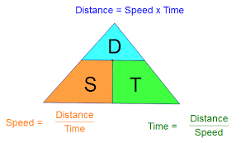

Solve the problems below by calculating the speed of each object.
- A plane left Glasgow at 7:45pm and flew 1107 miles to Lisbon in Portugal. The plane arrived at 10:45pm.
a) How long did the journey take?
b) What was the plane’s average speed?
- The first ferry to Liverpool leaves Dublin at 0750 and arrives in Liverpool at 1550.
Find the average speed of the ferry for the 144 mile trip.
- Henry decides to travel to the coast.
His outward journey takes him 2 hours to get there but the return journey takes one hour longer.
If Henry lives 30 miles from the coast, find his average speed for his round trip.
- A ship travels 48km in 3 hours and 23 minutes. Calculate the average speed of the ship.
- A cyclist covers 64 ½ km in 4 hours 15minutes. Calculate the average speed of the cyclist.
- A lady typed 20 words in 15 seconds. What is her typing speed in words per minute?
- The distance from Johannesburg to New York is 7968 miles. It takes on average 16 hours and 45 minutes to arrive in New York. What is the average speed of this plane?
- Joyce is driving a bus along a motorway with a speed limit of 70 miles per hour. In 30 minutes, she travels 36 miles. Is his average speed during this period exceeding the speed limit?

Pete needs to be at work for 9.00am. He leaves his house at 7.30am and drives to the gym which is 12.5 miles away. Pete spends 45 minutes in thegym then drives the reaming 9 miles to work.
- What average speed in, miles per hour, must Pete drive at to ensure he is not late for work?
- On Tuesday Pete spends 55 minutes in the gym. What average speed in miles per hour, must Pete drive at to ensure he is not late for work?

