Rights Respecting Schools: The article of the week for this week is

Article 12 Respect for the views of a child
Every child has the right to express their views, feelings and wishes in all matters affecting them, and to have their views considered and taken seriously

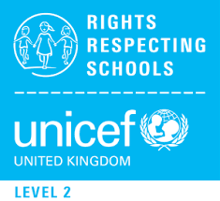
RRS Activity choices:

Activity 3 If you were to stand for election to your School Council next year what would you say in your speech or manifesto? Start drafting it now!

Activity 2
Have you ever thanked people at home who are good at listening to you? Design a card or picture, or write a letter to thank them for hearing your voice.

Activity1
Write a creative story, a poem, a short play script or a piece of art using the title ‘Head My Voice’. Share it with your teacher and class

