Struthers Primary School
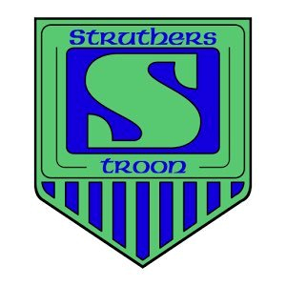
Embedding Maths Mastery 2018-19
Term 1 Focus: Concrete – Pictorial – Abstract
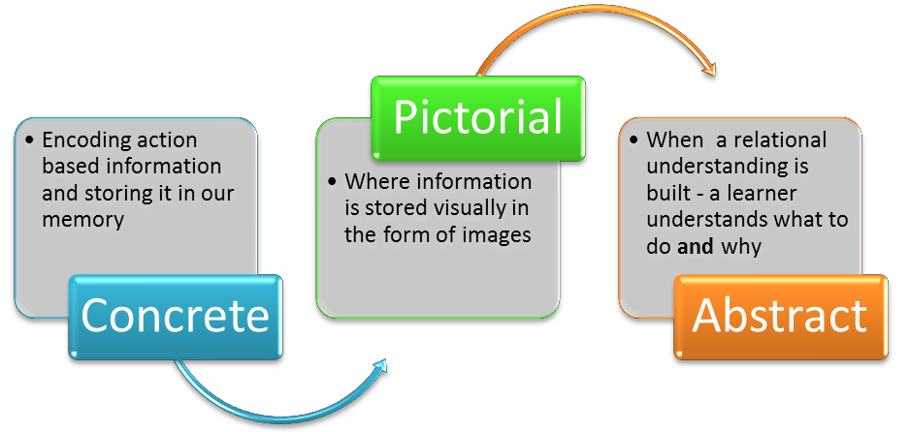

Glasgow Counts provides the following definition of CPA.
CPA is an approach to teaching mathematics based on the work of Jerome Bruner (1960). Bruner’s premise was that children’s conceptual understanding develops from being actively engaged in their learning and making sequential process through these three stages of representation: enactive, iconic and symbolic (mapped onto concrete, pictorial, abstract respectively). Each stage builds on the previous one, although unlike Pagetian theory, they are not age-related.
CPA therefore encompasses multiple models that approach a concept at different cognitive levels. Firstly at the concrete level, pupils are exposed to a range of appropriate manipulatives, for example, dienes, unifix, numicon, ten frames, straws, dot patterns, counters, shapes, coins and dice. Use of these concrete objects engaged children and young people with their learning and can provide a ‘hook’ into the learning. Another advantage of this approach is that discussion is a natural by-product of active learning which is an element of good quality maths teaching and learning (Williams, 2008).
Progress into the pictorial phase is consequently underpinned by active, memorable experiences leading to deep learning. The second phase aids visualisation and the bar model is a key element in providing a consistency in the pictorial phase of problem solving along with number lines, hundred squares, diagrams and pictures.
It is important to note that although the ultimate aim of a CPA strategy is to culminate in a fluent, abstract approach characterised by quick, efficient methods, the process should not be rushed. It may be necessary to return to previous phases to address pupils’ misconceptions and consolidate their conceptual understanding.
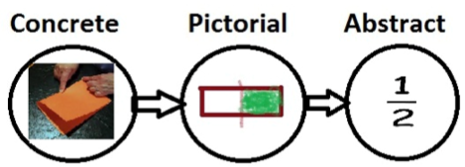
Another key feature of the CPA process is that although concrete objects may be perceived as too elementary for upper primary learners (Sousa, 2007), both concrete and pictorial representations should be used across all stages of learning.

Support for staff
- Collective CLPL delivered by Mrs Lockie at TSM May 2018
- ‘CPA Progression within calculations’ document for ideas of how to implement CPA in the learning and teaching of the four processes saved on the
Staff Shared Area – Numeracy – Maths Mastery - CPA
Term 2 Focus: Bar Modelling
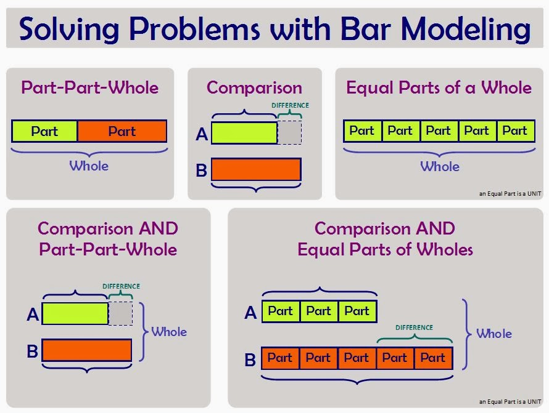
Bar modelling is an essential maths mastery strategy. A Singapore-style of maths model, bar modelling allows pupils to draw and visualize mathematical concepts to solve problems in a consistent way.
Bar modelling is an essential maths mastery strategy used to support children in problem solving. It is not a method for solving a problem, but a visual representation of a problem that support learners in gaining insight and clarity as to how to solve it.
It is a pictorial representation that can bridge the gap between concrete experiences and abstract methods. It can be used to represent problems involving the four operations, ratio, algebra and proportion.

Support for staff:
- Collective CLPL delivered by Mrs Lockie in Nov TSM
- Introduction of Barvember with links to daily problems provided and previous year’s problems shared on the Staff Shared Area – Numeracy – Maths Mastery – Barvember
- Opportunities provided for team teaching with Mrs Lockie

Term 3 Focus: Part-Part-Whole model

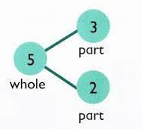
Part-part-whole thinking refers to how numbers can be split into parts. It allows learners to see the relationship between a number and its component parts. As a result, learners generalise the connections between addition and subtraction. Part-part-whole reasoning is a critical underpinning concept required for flexible and efficient computation. It also assists students’ attempts to visualise, interpret and solve word problems.
Part – Part – Whole models can be represented in a variety of ways and can be used at the concrete, pictorial and abstract stages.
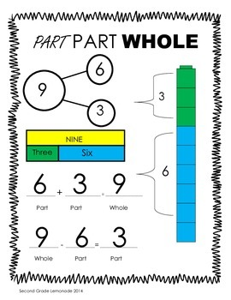
Support for Staff
- Part – part – whole packs provided for P1, 2 and 3 whilst being shared with all stages to support the learning and teaching of children with ASN
- Part-part-whole interactive teaching resources available in Staff Shared Area – Numeracy – Maths Mastery – PPW
Term 4 Focus: Show It, Draw It, Explain It, Prove It

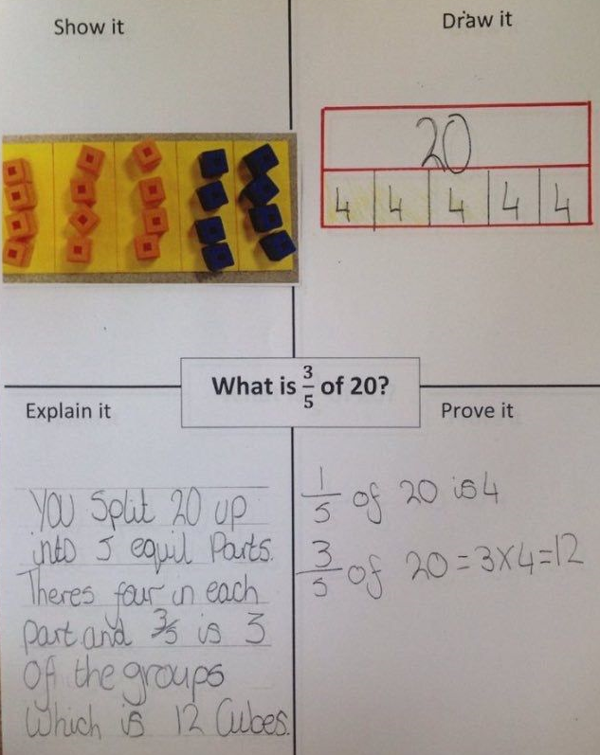
The ‘Show It, Draw It, Explain It, Prove It’ can be a useful tool for assessing a pupil’s the depth of a learner’s understanding of a concept, idea or strategy.

It can also be used as a teaching and learning strategy to deepen understanding, help with problem solving and develop reasoning. This approach is underpinned by Jo Boaler’s thoughts that multiple representations of a concept is more valuable than doing a page full of calculations.

Support for Staff
- Introduce to staff at April CSM
- Paper and interactive templates provided in the Staff Shared Area – Numeracy – Maths Mastery – multiple representations
- Ideas for use provided for all staff members with completed examples

