

**South Ayrshire Council**



Struthers Early Years Centre

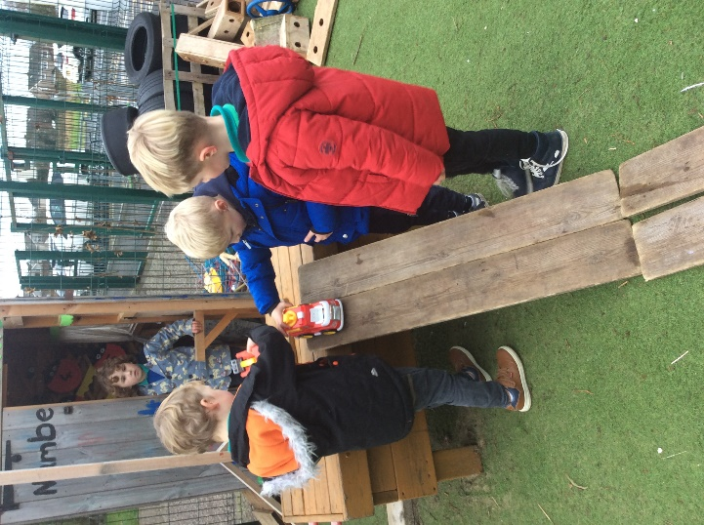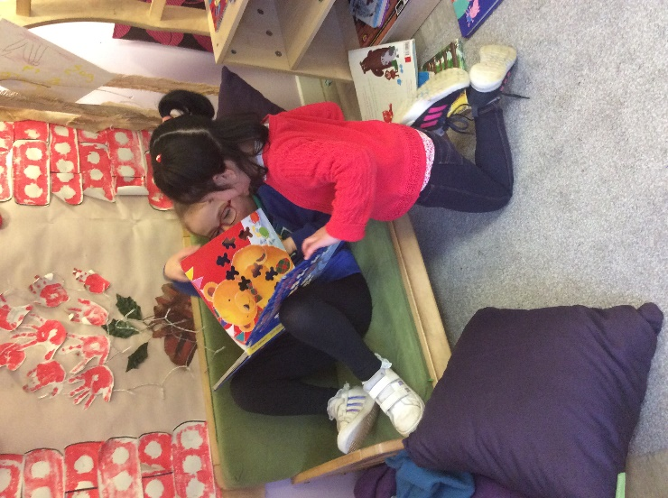

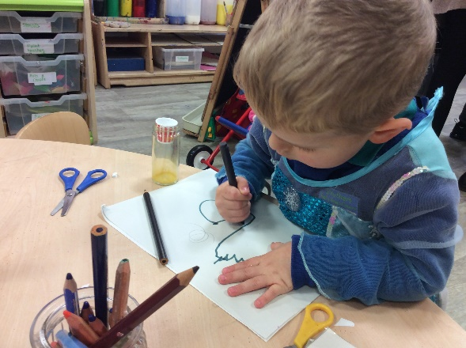

HANDBOOK – 2022/23

Contents

**SECTION A General School Information**

**SECTION C** **Home/School/Community**

1. Communications
2. Parental Involvement
3. Parents as Partners

4 Try at Home

**SECTION D** **Care and Welfare**

1. Child Protection
2. Quality Assurance
3. Parental Complaints Procedure
4. Introduction by Head Teacher
5. Statement of School Aims and Values
6. School Information
7. School Staff
8. Starting Early Years Centre
9. General Early Years Centre Information
10. Holidays and Transition
11. Enrolment

**SECTION B Teaching and Learning**

1. **Arrival and Collection/ Planning**
2. Early Years Centre Curriculum
3. A typical day in the Early Years Centre
4. Tracking your Child’s Progress and Achievementsditional Support Needs/ Equality
5. Promoting Positive Behaviour
6. Medical Information
7. Early Years Centre Information

##### Introduction by Head Teacher

Welcome!

Thank you for taking the time to read our Struthers Early Years Centre handbook.

As a school community we are delighted to welcome our new Ante and Pre School pupils into our Struthers family.

We will strive to provide the highest quality learning experiences for each individual child in a safe and nurturing environment.

This handbook aims to ensure you know all about the service we will provide and enable you to fully understand what you can expect from our Early Years Centre provision including learning experiences, routines and to reassure you that your child’s care and wellbeing are at the centre of all we do.

We work closely to our values of Respect, Honesty, Inclusion, Loyalty and Responsibility as a Rights Respecting School.

At Struthers Early Years Centre we aim to:

* Provide a safe and nurturing environment where your child will feel happy and secure and ready to thrive;
* Encourage the emotional, social, physical and intellectual development of your child;
* Encourage positive attitudes to self and others while developing confidence and self-esteem;
* Create a wide variety of opportunities for play in different environments;
* Encourage your child to explore the world and share their thoughts and feelings;
* Provide opportunities which stimulate interest and imagination and to extend your child’s ability to communicate ideas and feelings in different ways;
* Ensure your child has a smooth and supportive transition into the next stages of their learning.
* Ensure all guardians feel included and involved in the life of the Early Years Centre.

Please ask to speak to any member of our Early Years Centre staff or myself if you have any further questions and we will be happy to help. We look forward to working with your child and yourself in the future.



Kind regards,

Mrs Gail McKellar

Head Teacher.

Statement of School Aims and Values:

**Vision**

As a community we will ensure everyone who is part of Struthers Primary and Early Years Centre feels safe, included, valued, equal and happy supporting each individual to reach their full potential recognising and celebrating their achievements along their journey with us.

**Values**

Our Struthers Primary Values are Inclusion, Respect, Honesty, Kindness and Responsibility.



**Our School Aims**

* To provide a broad and balanced curriculum of excellence which meets each individuals’ needs and helps them reach their full potential.
* To provide a safe and secure learning environment which values each individual and the qualities they bring to our community.
* To develop in our pupils the knowledge and understanding of the world at large informing them about environmental, cultural and scientific matters and understanding their place in it.
* To work in close and effective partnerships with all our community partners to ensure our pupils have a creative approach to their curriculum and are effectively supported especially during transitions in their learning.

###### School Information

1. School Name Struthers Primary School
2. Address Staffin Road, Troon. KA10 7JB
3. Telephone/Fax 01292 690073
4. E-Mail **Struthers.Mail@south-ayrshire.gov.uk**
5. Projected Roll 305 & 60 (EYC)
6. Capacity 416

Parents should note that the working capacity of school may vary dependent upon the number of pupils at each stage and the way in which the classes are organised.

The basic method of allocating teachers to primary schools nationally is set down by SEED. The allocation is according to the total number of pupils on the school roll; no account is taken of the way in which pupils within any given school may happen to be distributed across the age bands.

The nationally agreed conditions of service for teachers set a normal maximum number of 25 pupils for classes of more than one stage i.e. composite class, 30 pupils for single stage classes P1-3 and 33 pupils for single stage classes P4-7.

During session 2022/23 along with our Early Years centre we will have the following classes: P1, P1, P2, P2, P3, P3, P4, P5/4, P5, P6, P7/6, and P7.

Composite classes, when required, are organised in maths or language working groups, social groups and gender. A pamphlet entitled **‘*A Guide to Parents-Composite Classes’*** is available on request from the school.

Details of the school’s catchment area and street names are available for inspection at the school and parents can also access them on the Council’s website at www.south-ayrshire.gov.uk

* + Struthers Primary is non-denominational
  + Struthers Primary is co-educational

Community Facilities are available in school. For further details of these please contact-

Karen Hepburn

Education, Culture and Lifelong Learning

County Buildings

Welling Square

Ayr KA7 1DR

Tel: 01292 612 655

karen.hepburn@south-ayrshire.gov.uk

School Staff

****

Senior Management Team

Head Teacher & Early Years Centre Manager – Mrs McKellar

Depute Head Teacher – Miss McBean

Principal Teacher – Mrs Lockie

Early Years Staff:

Depute Manager – Mrs Galloway

Class Teacher – Mrs McGuigan

Senior EYP – Miss Gass

Early Years Practitioners

Miss Paterson

Mrs Kennell

Miss Little – 0.5

Mrs Young

Miss Campbell

Miss Rossi

Mrs Rodger

Mrs Kerr – 0.4

School Assistants

Mrs M Boyd

Mrs D Caldwell

Mrs M Moore

Mrs L Curson

Mrs F Baird

Miss P Cameron

Mr C Harnett

Mrs C Flynn

Additional Support Teacher (0.2) – Mrs J Blackwood

Educational Psychologist – Katie Webster



School Staff (cont.)

Clerical Assistants

Mrs C. Maley

Mrs E. Smith

Mrs K. Allan

**School Nurse**  Ms Claire McMorland



**Cleaning Supervisor**  Mrs N. Johnstone



**Janitor**

Mr Dunn

**Lollipop Lady** Mrs N. Helliwell

****

Starting Early Years Centre

At Struthers we offer both morning and afternoon sessions for 30 children and have provision to accommodate some children for full day placements. There is an opportunity for 3 and 4 year olds to learn, play and mix together within these sessions. Having different ages working together is both a national and South Ayrshire priority and gives children an opportunity to learn together and support one another. As the Early Years Centre follows A Curriculum for Excellence and offers children experiences at Early Years level we are able to cater for individual needs and ensure children make progress at their own level of ability. Where 3 year olds experience a variety of activities at Early Level, 4 year olds are supported to build their knowledge and understanding and help to prepare them for their transition into Primary 1. Progress is regularly tracked by key workers and parents can discuss their child’s progress at any time throughout the year. Roughly each term there will be an opportunity to have a more formal ‘Personal Plan’ appointment meeting, during which you can review your child’s learning journey, discuss their progress and highlight any changes in their wellbeing/care needs to staff.

3 year olds will be admitted ***on the Monday after their third birthday***. If this is a holiday then their starting day will be the next working day. Parents are notified by letter of their child’s start date. Each child is assigned to a member of the Early Years Centre staff who will take responsibility for the child’s progress, assessment and care both in and out of the Early Years Centre. Parents/carers will be able to view the nursery environment on our website as due to COVID-19 we are unable to welcome you into the centre; however, we can offer garden visits to allow you to meet with your child’s keyworker.

**EARLY YEARS CENTRE HOURS (PUPILS ONLY)**

# **Morning Session**

# 8.00– 12.45 pm

**All Day Provision**

Option 1 – Monday Tuesday Wednesday

8:00–6.00pm / 8.00-12.30pm

Option 2 – Wednesday Thursday Friday

2.30-6.00pm / 8.00-6.00pm

**Afternoon Session**

1.15 – 6.00 pm

## **Clothing**

We love to get messy at Struthers Early Years Centre! There are messy play activities available every day such as, painting, craft, mud pie making, puddle painting and many more. Whilst we always try to ensure that aprons are worn, accidents do happen. Please dress in your child in suitable clothing for playing indoors and out. There are Early Years Centre polo shirts and sweatshirts available to buy if you wish, however they are not compulsory. You can purchase these from BE Schoolwear, 75 Dalblair Road, Ayr or www.border-embroideries.co.uk

We go outside everyday into our very own outdoor space and we will offer outdoor play and nature walks. It would be helpful if children were dressed appropriately for the seasonal changes in order to do this. You may wish to provide a pair of welly boots to be kept at Early Years Centre. We would just ask that you name all items. Both pre-school and ante pre-school children participate in PE and so we would be grateful if children were provided with a pair of soft-soled indoor gym shoes.

**Transition into P1**

There are many opportunities for pupils from the Early Years Centre to interact with teachers, staff and pupils from the primary school. All Early Years Centre children take part in school celebrations, special events and assemblies within the school. In addition Pre-School children visit Active Start and have Big Playground time. In Term 4, P1 teachers will visit. A profile (Learning Journey) is compiled for every child, and passed on to their Primary 1 teacher along with any other relevant information. This record enables the Primary One teacher to have a clear view of your child’s development and provide them with an appropriate curriculum for your child from the first day of Primary one. Visits to Primary One class bases for pre-school pupils are organised in the final term.

Parents of all pre-school pupils will receive a transition report from the Early Years Centre during term 4 and they will also have an opportunity to talk to the key worker at personal plan appointments. Parents will have an opportunity to ask questions about their child’s progress and to raise any concerns they may have regarding the important step of moving from Early Years Centre into Primary 1.

**Holidays**

Holidays change every year and you can find a list of all dates on the South Ayrshire Council website.

<https://www.south-ayrshire.gov.uk/article/24000/School-term-dates>

**Applying for an Early Years Centre Place**

The first step, should you wish your child to receive Early Years Centre education at Struthers Early Years Centre Class is to register. If a place is offered to your child then he/she will be formally enrolled.

WHO CAN APPLY FOR AN EARLY YEARS CENTRE PLACE

Parents/guardians of children who will be three years old by **29 February** can apply for an Early Years Centre place. Registration normally takes place at Struthers in February. This date is generally intimated in the local press and in local amenities. Parents/guardians should make one application to the Early Years Centre of their choice. They will be asked to state a second and third choice.

The South Ayrshire Council admissions policy is adhered to when allocating Early Years Centre places. The policy is set out below:-

|  |  |
| --- | --- |
| **PRIORITY 1** | “Children in need” (as defined by the Children in Scotland Act 1995 and identified by Social Work, Pyschological Services and Health Visitors etc.) a Priority One placement must be initiated by a Request for Assistance form and where appropriate a Wellbeing Assessment. |
| **PRIORITY 2** | Children who are deferring entry to Primary school. |
| **PRIORITY 3\*** | Children who reside in South Ayrshire currently attending the Early Years Centre applying for a place within the same centre. |
| **PRIORITY 4** | Children who reside in South-Ayrshire who will have a sibling(s) accessing early learning and childcare in the same centre. |

|  |  |
| --- | --- |
| **PRIORITY 5\*\*** | Children in SIMD decile 1-2 who reside in South Ayrshire. |
| **PRIORITY 6** | Children in \*\*\*SIMD decile 3-10 parents/carers in work, study or formal training who rside in South Ayrshire (declaration to be completed). |
| **PRIORITY 7** | All other children who reside in South Ayrshire. |
| **PRIORITY 8** | Children who reside out with the boundary of South Ayrshire Council but within the catchment area of a South Ayrshire Primary School. |
| **PRIORITY 9** | Children who reside out with the boundary of South Ayrshire Council. |
|  | |

**\* Priority 3: Excludes 2 year olds who have purchased sessions.**

**\*\* Priority 5 There may be circumstances where places are allocated by the Early Years Forum as a result of Requests for Assistance made by Social Work or Health Visitors.**

**\*\*\* The Scottish Index of Multiple Deprivation (SIMD) provides a wealth of information to help improve the understanding about the outcomes and circumstances of people living in Scotland. To find out more information about SIMD visit the link: https://www2.gov.scot/Topics/Statistics/SIMD**

Learning at the Nursery

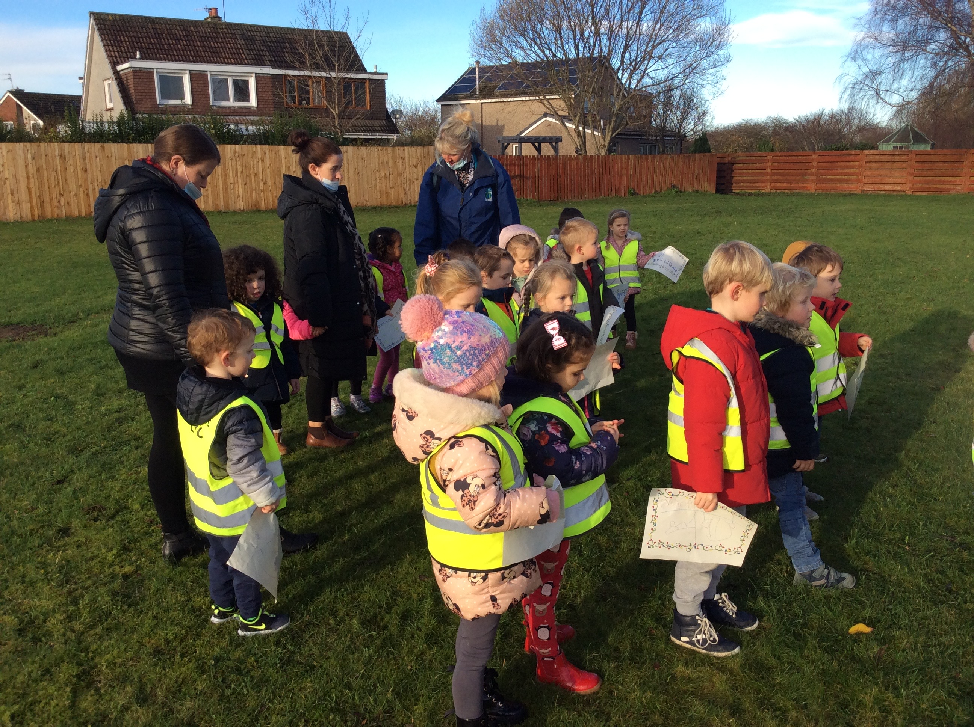

## 

## 

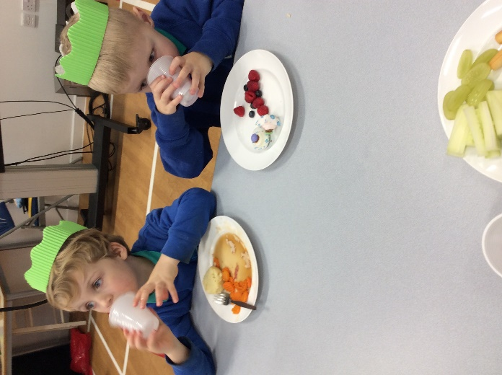

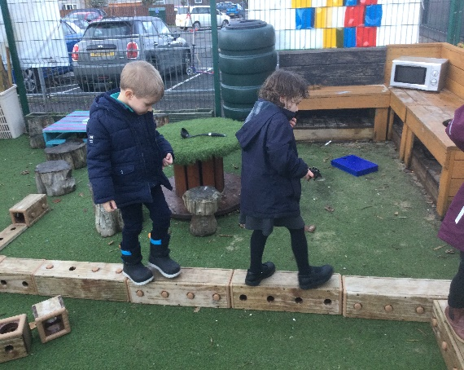

## **Arrival and collection of children**

j0351978Safety in school is of great importance. It is expected that a responsible adult brings and collects your child from the Early Years Centre each day. Please inform staff of any change of person collecting or dropping off your child. A password will be issued if someone new is collecting to ensure the safe hand over of your child.

Please enter the school grounds through the pedestrian gate at the front of the building and walk along the side of the

school using the path. Due to the new extension there is no access for parents to the school carpark.

The Early Years Centre door is supervised by a member of staff at the beginning and the end of each session. To gain access out with these times please use the buzzer system to gain entry.

**Planning**

We use information from parents and children/staff, to plan and provide interesting, challenging and achievable learning experiences taking account of the individual needs, stage of development and interests of each child.

The plan is then used in conjunction with the Curriculum for Excellence framework enabling a child’s progression towards future learning. All Early Years Centre staff are involved in planning sessions. Many of these take place with the children and the plans are monitored by the school management team on a regular basis to ensure continuity and progression.

Our planning is shared via weekly newsletters. This keeps you informed of current skills development and allows you to support this at home. We believe parents are their children’s first teachers and value your input. If you think you can offer an activity or have a suggestion that would complement our plans please let a key worker know. We also often offer Home-link activities related to current interests or focus for you to try via the app Seesaw.

|  |
| --- |
| Early Years Centre Curriculum  We aim to provide a well-balanced, planned programme of activities tailored to each individual child by providing suitable equipment in safe, nurturing surroundings. This will encourage the child’s natural curiosity and allow them the valuable opportunity to progress at their own pace in an educationally stimulating environment enabling them to achieve their full potential.    Children in our Early Years Centre class will participate in the experiences and outcomes of Curriculum for Excellence. The main curricular areas are:   * Expressive Arts – art, drama, music and dance * Health and wellbeing * Literacy * Mathematics * Religious Moral Education * Science * Social Studies * Technologies |

**Tracking your Child’s Progress and Achievements**

**How will I know how my child is doing?**

In the EYC staff will make non-intrusive observations of your child’s progress and development – recorded in individual profiles. They will then discuss these with you and complete a Personal Plan at several points throughout the year. With your input they will set appropriate next steps (nursery and/or home) for your child. At the heart of these observations, and of everything we do in nursery are GIRFEC and SHANARRI:

Getting it right for every child (GIRFEC) is the national approach to improving outcomes through public services that support the wellbeing of children and young people. Based on children’s and young people’s rights, it supports children, young people and their parents to work in partnership with the services that can help them.

Wellbeing is at the heart of GIRFEC and a SHANARRI wheel has been created which highlights ‘eight indicators of wellbeing’ every child needs to experience in order to reach their potential. In the nursery it is our duty to support your child to be safe, healthy, active, nurtured, achieving, respected, responsible and included. These indicators are therefore used when taking observations of your child and in planning their next steps. You will see them in both your child’s profile and personal plans.

For more info visit <http://www.gov.scot/Topics/People/Young-People/gettingitright/well-being>

There are Pre School Developmental Milestones created by South Ayrshire Council which relate directly to skills and experiences in Literacy, Numeracy and Health and Wellbeing outlined in the national curriculum (ACfE). Staff will track your pre-school child’s progress within these, with formal recording periods being September and May. Whilst your child may not have met many of the milestones in September it would be expected that your child meets the **majority** of these by May of their pre-school year. Staff may discuss particular supports that they will put in place to help your child achieve the milestones throughout the year and also equip you with strategies to support these at home. The milestones should be discussed during your pre-schoolers’ personal plan appointment.

## In addition to this we write a formal transition report for pre-school children in May. We share updates via email and through the bulletin and will always readily discuss achievements/concerns as necessary at pick up/drop off.

Achievements are celebrated regularly in the EYC. These can be recorded in the child’s profile and are often shared at group times with other children. You can share these via our app Seesaw.

## **A Typical Day in the Early Years Centre**

Our session starts with a ‘soft start’. Your child will come in, wash their hands, sign their name, pop their snack card on the fridge and choose an activity. During the session we call a ‘Together Time’ where we explore a variety of learning experiences, for example, sharing news, rhyme or numeracy work. Children are free to choose activities for the majority of the session. When weather allows we open our garden doors and children have free flow access throughout the session.

We provide a range of experiences, most are self-select to promote independence but some will be planned by staff to develop key skills such as fine and gross motor, early literacy and numeracy and social development. Children can request games and activities on our I-pads and whiteboards, music to listen to, or activities they have had before. Staff are responsive to the needs and interests of the children. We often ask our children what they would like to learn about and staff then plan experiences around these interests.

Throughout the week we will visit the gym, the ‘big’ playground, play on pedals and take part in bookbug sessions. Sometimes we go on outings to the local community, further afield and attend whole school assemblies. You will be informed in advance of these events.

During and towards the end of the session your child may participate in a small group activity – this may be with their key worker group, a randomly selected group or with children of their age (ante-pre/pre). Small groups provide more 1-1 interaction and quiet focussed time. Working with a variety of groups supports your child to develop a variety of friendships in the nursery.

At the end of the session we have another together time to review the session and also sing rhymes or share a story.

## **Children with Additional Support Needs**

Each child progresses as an individual. Pupils who may be experiencing difficulties will be given additional support within the Early Years Centre setting by Early Years Centre staff. The head teacher, staff, parents and other professionals in consultation can help to provide appropriate learning experiences for each child. The Staged Intervention process in school encourages any issues to be addressed early, often minimising or even preventing problems later on.

**Equality**

All children are encouraged to develop positive attitudes towards others whose gender, language, religion or culture for example is different from their own.

Parents from Ethnic Minorities who celebrate particular religious festivals may wish their children to be absent in order to attend religious events. Such occasions will be supported by the establishment.

At Struthers Primary we aim to provide children with an educational and social environment, which will enable all children to reach their full potential irrespective of race, creed, sex or religion. It is our intention that no resources presented to the children should contain material that could be considered offensive to any sectors of the community. In our present multicultural society, we hope to foster an attitude of respect and tolerance to different races and ethnic minorities and expect each pupil to treat others, as they themselves would expect to be treated.[](http://images.google.com/imgres?q=children&hl=en&gbv=2&biw=1280&bih=856&tbm=isch&tbnid=3aHqC-duIFnxnM:&imgrefurl=http://www.robertsdaleumc.com/379183&docid=ZpNGt5rhQKr7bM&imgurl=http://www.robertsdaleumc.com/clientimages/27099/friendship-circle-clip-art.jpg&w=900&h=900&ei=jJzwToKlGsTKhAerpYm1AQ&zoom=1) To promote this statement we undertake to: -

1. Make all areas of the curriculum available to boys and girls alike.

2. Apply disciplinary measures in a uniform manner to both sexes.

3. Allocate tasks within the school fairly.

4. Avoid the use of any language, or texts, by staff or pupils, which could be looked upon as racist or sexist.

# #

###### **Promoting Positive Behaviour**

*Personal, social and emotional development is* about “*emotional well-being, knowing who you are and where you fit in and feeling good about yourself. It is also about developing respect for others, social competence and a positive disposition to learn*.”

Personal, social and emotional development is vital for success all areas of learning.

Promoting positive behaviour though group discussions and other strategies in the Early Years Centre can help to equip pupils with these skills. Planned activities during group/together times encourage pupils to explore, experiment, plan and make decisions for themselves. Group times encourage pupils to talk about their own experiences, take turns, share and co-operate. They provides pupils opportunities to form relationships with adults and other children.

**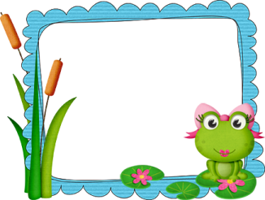**

Every child has the right to be the best they can be.

Article: 29

At Struthers Early Years Centre Class we follow the school’s Right Path Reminders as part of a Rights Respecting School. At the beginning of each session we use these and the Rights of the Child to help create ‘Golden Rules’ or class charter with the children. As these are created through discussion with the children they may change from year to year and staff should keep you updated. Our previous Golden Rules are displayed overleaf.

|  |  |
| --- | --- |
| **Right Path Reminder** | **Link to the UNCRC Article** |
| We look after property in our school. | Article 28: Your right to learn and go to school. |
| We are honest, we don’t cover up the truth. | Article 12: Your right to say what you think and be listened to. |
| We work hard to be the best we can be. | Article 29: Your right to be the best you can be.  Article 28: Your right to learn and go to school. |
| We listen to pupils and teachers opinions. | Article 12: Your right to say what you think and be listened to. |
| We are gentle, we don’t hurt others. | Article 19: Your right to be kept safe. |
| We are kind and helpful, we don’t hurt anybody’s feelings. | Article 19: Your right to be kept safe.  Article 15: Your right to meet with friends, join clubs and groups.  Article 31: Your right to relax and play. |

[](http://www.123magic.com/)We utilise 123 Magic at Struthers Primary to support children to follow the agreed Golden Rules.1-2-3 Magic provides proven strategies and solutions to help parents and teachers create an environment that's encouraging to learn in.

If negative behaviour is demonstrated the following123 Magic strategies will be used.

Firstly a member of staff or parent will highlight that they are unhappy with the behaviour in a calm but firm voice (no shouting). This could be enough to draw their attention to the fact that they have made a wrong decision and need to stop and change their actions. If behaviour does not change you would follow the strategies below.

**Count 1** - wait 5 seconds for child to change behaviour.

If no change

**Count 2** - wait 5 seconds for child to change behaviour and explain clearly that there will be a time out if there is no change.

If no change

**Count 3** - take 5, Send child to allocated time out place for 3 -5 minutes depending on age and stage

Time out does not begin until child is calm.

The staff will be able to answer any questions that you may have.

More information can be found on the website using the link below.

[**http://www.123magic.com**](http://www.123magic.com)

**EYC Golden Rules**

At Struthers Primary our core values are

:

**Honesty** **Kindness** **Respect** **Inclusion** **Responsibility**

In our EYC our **‘Golden Rules’** are:

We use kind hands.

We use walking feet.

We use listening ears.

We are sharing and caring.

We help up to tidy up

We are a Rights Respecting School and when we follow our Golden rules we are respecting each other’s right to play, learn, make friends and be safe.

We encourage the children to Stay, Play, Put Away!

## **Medical information**

PE03678_Medical Conditions and Medication

Please inform staff in the Early Years Centre of any absence by telephone call.

It is very important that Early Years Centre staff are aware of any medical problems that your child may have. They are treated confidentially. Please inform staff on arrival of any medical conditions and requirements so that an appropriate plan can be put in pace. If your child suffers from asthma, please inform staff of any activities, which may trigger an attack. Inhalers and any other medication may only be administered to pupils by staff after arrangements are made through the Early Years Depute Manager. If your child requires temporary medication for any reason, you must let EYC staff know. There is associated paperwork to be completed regarding the storage and administration of the medication. On completing this paperwork you MUST let staff know if medication has already been administered and the dose.

Routine Health Checks

Health professionals, such as the nurse, doctor and dentist visit the Early Years Centre regularly to speak to the children. Parents will be issued with letters and permission slips for pupils to receive routine eye tests, during the pre-school year. Should you have any concerns about medical issues, please speak with Early Years Centre staff.

Accidents and Incidents

Early Years Centre staff are first aid trained and minor accidents and upsets which occur in Early Years Centre are dealt with by staff. Should further support be required, a qualified first aider is on hand in the school. If your child becomes unwell at any time during Early Years Centre, staff will contact parents. If you are unavailable, the emergency contact will be used. Please inform staff of any changes to circumstances so that the contacts are up to date. All accidents are recorded - outlining what happened and the steps taken by the staff. The adult collecting the child will be fully informed by staff about any incidents and will be asked to sign a record to acknowledge that they have been notified about the accident and any appropriate actions required to be taken.

## **Snack and Healthy Eating**

Healthy eating is promoted at snack time. Milk and water are available each day along with a variety of snacks. It is vital that parents inform Early Years Centre staff if any children have food allergies or of any foods which they do not wish their children to try.

## **Tooth brushing**

Struthers Early Years Centre encourages tooth brushing after snack. The Tooth brushing scheme is managed and maintained by the Department of Dental Health Promotion and Epidemiology. They provide children with toothbrushes and information and practical demonstrations on how to care for their teeth. If you do not wish your child to participate in this scheme please let a member of staff know.

##### **Parental contributions**

****Donations of “junk”, cardboard, cartons and newspapers are greatly appreciated. We do highlight our ‘Wish List’ on our weekly newsletter for anyone who is able to kindly donate.

## **BALONBNRBirthdays**

As a health promoting Early Years Centre we ask that you please **do not** send in a birthday cake. On this special day your child will be able to lead the learning in the Early Years Centre by bringing in a favourite CD or game for us to share and play and making it about their favourite things. Please note that the Early Years Centre does not promote giving out sweets to other children from the birthday person.

## **Fire Drills**

BELLFire drills take place within the school on a regular basis. Procedures for evacuating the building are placed throughout the Early Years Centre. Children rehearse fire drill procedure within the Early Years Centre.

**Smoking**

## Struthers Primary School is a smoke free zone in accordance with South Ayrshire Council policy. It would be helpful if parents and visitors to the school could refrain from smoking in the building and in the playground. We appreciate your co-operation in this matter.

## **Outings**

We love to get out and about at Struthers Early Years Centre and throughout the Early Years Centre year there will be many planned whole Early Years Centre outings which you will be informed about in advance. In your child’s welcome pack you will find some annual consent forms to be returned. Another consent will be issued before each whole Early Years Centre outing. We may look for volunteers to support these

ventures so please inform a member of staff if you are available to help out.

**Wandering Wednesdays**

In addition to whole Early Years Centre trips we take our learning out of the Early Years Centre each Wednesday with a wander around the local community. You will find a consent form for this in your welcome pack. We sometimes go on shape, number or letter hunts around the school grounds but can go further afield to the library, beach and even Dundonald Castle! The children benefit from these outings as it provides a real life context for their learning. Some examples of the skills children develop when out and about include road safety, reading signs, handling money and gaining an understanding of the wider world of work – not to mention the exercise and fresh air! You will be informed of our plan for our wander in our weekly newsletter and any additional consents will be issued if necessary. Please be aware that we do use public transport on these outings, including local buses, if you have any concerns about this please do not hesitate to contact a member of staff.

## **Emergency Closure Procedures**

Schools may be affected by adverse weather, temporary interruption of transport, power failures or difficulties of power supply. Should evacuation be necessary, children will be taken to **Muirhead Community Centre.** The staff shall make every effort to inform parents about details of the closure and re-opening as soon as possible. We shall keep in touch with parents using school website, letters, notices in local shops, announcements in public places and announcements in press and local radio.

##### **Photographer**

The photographer visits the school each year. Parents will be kept fully informed of dates for this.

j0440422

**Communications**

Struthers Early Years Centre is a lively and busy place and we endeavour to keep you up to date with all that is going on!

There are a variety of ways we will communicate with you to keep informed of your child’s progress and achievements and also to keep you abreast of any changes or upcoming events in the Early Years Centre.

**Open Door Policy**

We have an open-door policy at Struthers which means staff will be available at the beginning and end of each session to discuss any queries or concerns that you may have.

**Personal Plan Appointments**

Throughout the year a member of staff will ask you to update your child’s Personal Plan. These are documents which outline any specific requirements your child has. You should note any significant changes that have happened at home that may have an impact on your child. Think both big and small as some things which may seem insignificant to adults can often have an impact on children – from moving house to pet fish passing! You will be asked to reflect on your child’s wellbeing needs prior to the meeting, there is a leaflet provided in your welcome pack to support you with this. Finally you will be asked to agree some appropriate targets for your child to work towards at Early Years Centre. Personal Plans are updated termly or more often if necessary. You may ask to see your child’s Care Plan at any given time and can request to update this as necessary.

**Formal Reports**

At the end of your child’s pre-school year they will receive a detailed transition report and an appointment to discuss their progress in Early Years Centre and any information regarding their move to Primary 1.

We are aware many parents will not be dropping off/picking up their child from Early Years Centre due to other commitments and therefore also offer another chance for a meeting to discuss your child’s progress.

**Struthers Early Years Centre Online**

The Early Years Centre has a tab on our school website where we post useful information.

<http://struthers.sayr.sch.uk/our-classes.html>

**Email**

We also use an emailing system to inform parents of upcoming news, our weekly newsletter and various other information. We encourage you to use it as a platform of communication, as we don’t always see parents at drop off and collection times due to work commitments. Please give your email to a member of staff on arrival and we can get you added to our email group.

**Twitter**

Join us on Twitter!

Download the Twitter App today and follow us @StruthersSchool @StruthersEYC

At Struthers Primary and Early Years Centre we aim to use Twitter to:

* Promote the school
* Provide information to current and prospective parents and teachers as well as the wider community
* Act as a one way communication channel outwards (Please continue to contact the school directly with any questions)
* Showcase examples of pupils’ work – in words, pictures, sound or movie clips

**Parental Involvement**

We would encourage parents and carers to get involved with their child’s Early Years Centre experience as much as possible. We offer many opportunities for you to become involved and greatly appreciate the ongoing support we have from our parents.

**Stay ‘n’ Play**

*(on hold currently due to COVID-19)*

Each month we offer a Stay n Play date where you are invited into the Early Years Centre for 50 minutes to spend time with your child. Sometimes this will be a normal session and your child can show you the activities that they enjoy doing, you can observe them interacting with other children and also get to know some of our other parents. On other occasions there may be planned activities that the children will lead or we will use this as a showcase experience to show off some songs, dances or games we have learned! The children love being able to show off their Early Years Centre and all the things they have learned!

**PEEP (Parents in Early Education Partnership)**

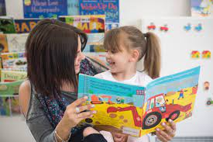South Ayrshire Council deliver PEEP classes for a block of six weeks in our Early Years Centre. You will be informed of these dates around a fortnight before they begin. The classes cover a range of activities for children aged 0-5 years and also offer tips and ideas for supporting your child’s development. The classes are great fun and are open to parents who have younger children not yet at Early Years Centre as well as our existing parents so please feel free to bring along a friend!



**Parents as Partners**

**Parent Council and Parent Forum**

* The Parent Forum decides how their representatives on the Parent Council are chosen and how the Parent Council operates. Parents are encouraged to volunteer or put themselves forward to be chosen as representatives of the Parent Council if they wish.
* The main aims of the Parent Council are to:
* support the school in its work with pupils
* represent the views of parents
* promote contact between the school, parents, pupils, providers of Early Years Centre education and the community
* report to the Parent Forum
* be involved in the appointment of senior promoted staff.
* raise funds for the school for the benefit of pupils (in some schools the PTA/PA fulfils this role).
* The parent council are also responsible for organising fundraising activities to raise money for the school. This allows us to buy extras that will benefit our pupils, these have included iPads and audio equipment. The group meets approximately once per term in the school to organise events. In the future the Early Years Centre will benefit from many of the fund raising events and activities. The Fundraising Group are always looking for volunteers and helpers throughout the year!

Parent Councils are the formal representative body for parents with children attending school. Parent Councils are different in each school to enable them to meet the needs of parents locally. Parents are welcomed to be:

* Involved with their child’s education and learning;
* be active participants in the life of the school; and
* express their views on school education generally and work in partnership with their children's schools.

All parents / carers are automatically members of the Parent Forum at their child’s school. As a member of the Parent Forum all parents can expect to:-

* receive information about the school and its activities;
* hear about what partnership with parents means in our school;
* be invited to be involved in ways and times that suit you;
* identify issues you want the parent council, to work on with the school;
* be asked your opinion by the parent council on issues relating to the school and the education it provides;
* work in partnership with staff; and
* enjoy taking part in the life of the school in whatever way possible.

**Try at Home** (On hold at present due to COVID-19)

At Struthers Early Years Centre we believe that parents and carers are their child’s first, and most important, educator. We want you to enjoy activities and early learning opportunities at home with your child. We therefore provide a variety of activities and ideas for you to enjoy at home.

**Lending Library**

We have a lending library in our Early Years Centre. This is in our Foyer and you are welcome to take a book at any point. We also use this as a more formal affaire and we take groups of children each week to the library to explore. Here they can choose a book to take home for the week for you to enjoy. Reading to your child is of huge importance to their early literacy development and we hope you enjoy this opportunity to share stories with your little one.

**Story Sacks and Activity bags**

We have several ‘Story Sacks’ and activity bags in our Foyer which you are welcome to take home for a few nights and enjoy. They may be favourite stories or centres around areas of learning such as ‘Healthy Eating’ or Number. If borrowing a sack please sign it out in the sign out book and let us know if anything goes missing or gets damaged so we can replace it as soon as possible.



**Child Protection**

School staff provides support to children and young people in their daily work and have a vital role to help protect them from harm. School staff helps keep children and young people safe and well by:

* Helping them learn about their personal safety
* Being a trusted adult who children and young people may turn to for help, and who will take them seriously
* Identifying when children and young people may need help
* Understanding the steps that must be taken when there are concerns for children’s and young people’s safety and well-being.

The school’s Child Protection Co-ordinator is Miss McBean, Deputy Head Teacher, who will co-ordinate the school’s response to concerns for children and young people’s safety and wellbeing. The Authority has a designated officer for Child Protection who will ensure schools work effectively to keep children safe and well. If you have any concerns about the safety and wellbeing of a child or young person, including a ‘gut feeling’, talk about this to the school’s Child Protection Co-ordinator or another member of staff.

A copy of the Child Protection Policy is available on request.

**Quality Assurance**

As a registered centre, our Early Years Centre is inspected regularly by the Care Inspectorate and will be included in a joint Care Inspectorate / HMIE inspection programme.

A rigorous monitoring and evaluation programme developed within the school ensures high standards are kept in all aspects of the service. This is undertaken by all Early Years Centre staff as well as the school management team.

[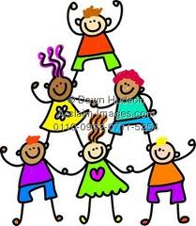](http://images.google.com/imgres?q=pupils&hl=en&gbv=2&biw=1280&bih=856&tbm=isch&tbnid=D1G_JXlyPe316M:&imgrefurl=http://acclaimimages.com/search_terms/pupils.html&docid=dcD_b2VGCh_k9M&imgurl=http://acclaimimages.com/_gallery/_images_n300/pupils.jpg&w=262&h=300&ei=GZvwTsmrLNCwhAepwL28AQ&zoom=1)

**DATA PROTECTION ACT**

***Personal information on children, their parents or guardians may be processed for teaching, registration, assessment or other administrative duties. The information is protected by The General Data Protection Regulation 2018 and will only be disclosed in accordance with the appropriate code of practice.***

**Do you want to make a suggestion, comment or complaint?**

If you would like to talk to someone we operate an open door policy at Struthers Early Years Centre. Please feel free to discuss any concerns you may have with Mrs Galloway, Early Years Depute Manager or make an appointment with the Head Teacher.

The Care Inspectorate is a national organisation set up to regulate and inspect the care and social work services, and child protection. It is a non-departmental public body and will operate independently of the Scottish Executive. They can be contacted over any concerns you may have regarding the service provided to your child.

You can contact Care Inspectorate at the address below.

Educational Services

County Buildings

Wellington Square

Ayr

KA7 1DR

Telephone: 0300 123 0900

Care Inspectorate

Compass House

11 Riverside Drive

Dundee

DD1 4NY

Tel: 03456009527

E-mail enquiries:

[enquiries@careinspectorate.com](mailto:enquiries@careinspectorate.com)

Parental Feedback

My child found her first couple of weeks tricky with a lot of tears and all staff were so patient and nurturing which really helped her settle in. I am extremely happy with the excellent service Struthers EYC is providing for my daughter.

All staff members have been so welcoming to my child entering the Early Years Centre. They go above and beyond to hold information sessions for parents, opportunities to visit the Early Years Centre before starting and providing a very informative welcome pack and handbook.

My daughter has enjoyed the variety of activities and experiences provided. Staff are always available to talk to and provide a nurturing environment for children.

I am absolutely delighted with the standard of care this service offers. My child moved from another nursery and settled extremely quickly due to the wonderful staff and stimulating and engaging environment.

We have been going to Struthers Early Years Centre since it opened and have watched it become by far the best Early Years Centre around. The teachers, the environment and all the resources ensure the children are very well looked after and encouraged to become well educated and independent with solid friendships before starting school.

My son has had a fantastic time at Struthers Early Years Centre! He absolutely loves it. It’s a great learning environment, the teachers and Early Years Centre staff have been brilliant!

We feel he has progressed so well and is always so happy to go to Early Years Centre. His drawing, writing and numbers have all improved. The teachers have made it so engaging for him. I think he will miss everyone!

My daughter has had a ball at Struthers Early Years Centre! She has enjoyed every aspect of being part of a loving, caring environment and has thrived as a result of this. Many thanks!

My daughter has had an exceptional experience at Struthers Early Years Centre having started in ante-pre in 2015. She has developed from a shy little girl into a polite and confident girl ready for school. She can count to 100 and write her full name as well as so many other skills learned during her time at Struthers Early Years Centre. In her own words “Struthers is brilliant”.

Thank you for taking the time to read through our handbook. We hope you found it beneficial. If you have any queries don’t hesitate to get in touch:

*Mrs Galloway – Early Years Depute Manager*

[*Pauline.galloway@south-ayrshire.gov.uk*](mailto:Pauline.galloway@south-ayrshire.gov.uk)

*01292 319261*

We look forward to meeting you☺!

Struthers Early Years Centre

